A PROJECT REPORT

On

“Cash flow statement analysis of sun pharmaceutical industry ltd’’

SUBMITTED TO HP UNIVERSITY SHIMLA



In partial fulfilment of the requirement for the award of the degree of bachelor of business administration in

SWAMI VIVEKANANDA GOVT. COLLEGE GHUMARWIN

FOR SESSION 2021-2022

SUPERVISON BY: SUBMITTED BY:

Mr. Naresh Kumar Akshit Sharma

Asst. Prof. (BBA) BBA 6TH SEM

Uni. Roll. 5190350003

**DECLARATION**

I **AKSHIT SHARMA** hereby declare that the project report was submitted by me under the supervision and guidance of Assistant Prof. Naresh kumar project guide college of **SWAMI VIVEKANAND GOVERMENT COLLEGE, GHUMARWIN** in partial fulfilment of BBA 6th semester. I further declare that I am solely responsible for omission and commission of errors if any.

DATE: Signature

**ACKNOWLEDGMENT**

“Acknowledgement is an art, one can write glib stanzas without meaning a word, on other hand one can make a simple expression of gratitude” I take the opportunity to express my gratitude to all of them who in some or other way helped me to accomplish this challenging training in “**CASH FLOW STATEMENT ANALYSIS OF SUN PHARMACEUTICAL INDUSTRY LTD.** no amount of written expression is sufficient to show my deepest sense of reference to Principal Prof. Ramkrishan, Co-ordinator Assistant Prof. Rajender Kumar and Assistant Prof. Naresh kumar (Project Guide). I also express deepest gratitude to my family for their blessing and good wishes.

I also acknowledge with a deep sense of reverence, my gratitude towards my parents and my friends who directly or indirectly help me.

**CERTIFICATE**

This is to certify that the report entitle “CASH FLOW STATEMENT ANALYSIS” for the award of the degree of Bachelor of Business Administration (BBA) from SWAMI VIVEKANAND GOVT. COLLEGE, GHUMARWIN (HP), Is a record to project report carried out by **AKSHIT SHARMA BBA 6TH Sem. UNIV. ROLL No.5190350003** under my supervision and guidance, no part of this report has been submitted to any other Degree /Diploma and this report may be taken for evaluation.

**Sign of Student**  **Sign of Guide**

**Sign of Coordinator**

TABLE OF CONTENTS

|  |  |  |
| --- | --- | --- |
| SR.NO. | TITLE OF THE CHAPTER | PAGE NUMBER |
| 1. | Company profile | **1-8** |
| 2. | Introduction to the topic  Need and Objectives of study | **9-13** |
| 3. | Review of literature | **14-22** |
| 4. | Data analysis & interpretation | **23-29** |
| 5. | Findings & Suggestions  Conclusion of study | **30-32** |
| 6. | Bibliography | **33** |
| 7. | Annexure | **34-41** |

**CHAPTER 1**

**COMPANY PROFILE**

**COMPANY PROFILE**



Sun Pharmaceutical Industries Ltd. (Sun Pharma) is the fourth largest specialty generic pharmaceutical company in the world with global revenues of over US$ 4.5 billion. Supported by more than 40 manufacturing facilities, we provide high-quality, affordable medicines, trusted by healthcare professionals and patients, to more than 100 countries across the globe.

Sun pharmaceutical industry produce products pharmaceuticals branded generic drugs over the counter drugs.

**History**

Operating income

Increase ₹50.10 billion (US$660 million) (2021)

Sun Pharmaceuticals was founded by Dilip shangvi in 1983 in Vapi, Gujarat, with five products to treat psychiatry ailments. Cardiology products were introduced in 1987 followed by gastroenterology products in 1989. Today it is ranked No.1 by prescriptions with 9 different classes of doctors in India and a market leader in cardiology, gastroenterology, ortho, diabetology, dermatology, urology, and vitamins / minerals / nutrients.

The 2014 acquisition of Ranbaxy made Sun Pharma the largest pharma company in India, the largest Indian pharma company in the US, and the 4th largest specialty generic company globally.

Sun pharmaceutical industry limited is an Indian multinational pharmaceutical company headquartered in Mumbai Maharashtra, that manufactured and sells pharmaceutical formulations and active pharmaceutical ingredients in more than 100 country across the globe. Congratulation to our regional excellence awards PY 21-22.



**Diversified Specialty and Generics Portfolio**

We manufacture and market a large basket of pharmaceutical formulations covering a broad spectrum of chronic and acute therapies. It includes generics, branded generics, specialty, complex or difficult to make technology-intensive products,

Over the counter (OTC), antiretrovirals (ARVs), Active Pharmaceutical Ingredients (APIs) and Intermediates.



**Global Footprint**

From humble beginnings in 1983, Sun Pharma has grown to become one of the largest generic pharmaceutical companies worldwide. We are the largest pharmaceutical company in India.

In the US, we are among the top 10 generic pharmaceutical companies and are ranked second by prescriptions in the generic dermatology market.

We are the largest Indian company in emerging markets with a presence in over 80 markets.

**Mission** – We believe that our mission is to provide high-quality and innovative medicines to people in the world by leveraging our strengths fully with our vision of “Reaching People. Touching Lives.” Advocated by Sun Pharmaceutical industry ltd

**Vision** – Our vision has been conceived keeping an eye on what we are and what we aspire to be. To attain this vision, it is important for us to align ourselves with a clear focus on achieving business goals. At Sun, we have always been guided by certain ideologies that have helped us to be successful. These are Humility, Integrity, and Passion & Innovation. Together, we have named it SUNOLOGY, a combination of Sun + ideology.

**Innovation-**

Our early investments in R&D, beginning three decades ago has enabled us to make technology a key differentiator. Our core strength lies in our ability to excel in developing generics and technologically complex products through focused teams in formulations, process chemistry and analytical development.



**Our Research Philosophy**

Science is at the heart of Sun. Our scientists work closely withdoctors, patients and the business development teams to generate innovative concepts and ideas to harness both, market needs and synergies across therapeutic areas. Whether it is specialty, generics, difficult to make technology intensive products, Active Pharmaceutical Ingredients (APIs) or Novel Drug Delivery Systems (NDDS), our scientists have tcapability to deliver high quality products to fulfil the unmet need in the marketplace.

**Technology**

Our capabilities span the development of differentiated products including liposomal delivery, inhalers, lyophilised injections, nasal sprays besides developing controlled and modified release dosage forms. We are also pioneers in delivery systems of ophthalmology, cardiology, peptides, CNS and oncology.

**Strong Intellectual Property**

Our research strategy and implementation are well supported by a strong Intellectual property team having expertise and experience in chemistry, analytical techniques, dosage forms and global patent law. Sun files numerous patents every year to protect its intellectual property in markets of interest. We have more than 1400 patents to our credit .Our R&D center have been audited and approved by international regulatory authorities, including the US FDA and European authorities.

**Our vision**

Reaching people and touching lives globally as a leading provider of valued

Medicine

**Our value**

Our value represent our promise to our stakeholders.

**Quality**

Get it right the first time

**Consistency**

Endeavour to bring new products to the mark and consistently deliver value to stakeholders

**CHAPTER-2**

**INTRODUCTION**

**INTRODUCTION PREPERATION OF CASH FLOW ANALYSIS:**

An organization should prepare a cash flow statement according to accounting standered-3. The following basic information’s are required for the pr3peration of a cash flow statement:

1. Comparative balance sheets
2. Profit and loss account
3. Additional data.

This statement is prepared in three stages as given below;

Net profit before taxation and extraordinary items.

Cash flow from operating, investing and financing activity

Introduction of cash flow

Cash flow is a measure of how much cash a business brought in spent in total turnover a period of time. Cash typically broken down into cash flow from operating activities, investing and financing activities on the statement of cash flow a common financial statement.

**Need and Objectives of the study**

The importance of cash flow statement is that **it is used to measure the cash position of the business** i.e. the inflow and outflow of cash and cash equivalents in the business for an accounting year and it also helps the business to know the availability of cash in their business.

1. short term planning
2. provides the detail where money is spent.
3. creating excess cash.
4. revealing the cash planning result.
5. long term planning.

Importance of cash flow statement

Cash flow statement analysis show the changes of cash flow and analyzing the operating, investing and financing activities. Provide insights about the liquidity and solvency of a firm, which is vital for the survival and growth of any firm

Cash flow statement is a provide long term planning which help predict the future

**However the main objective of cash flow statement**

1. **Measurement of the cash**

Inflows of cash and outflows of cash can be measured annually which arise from operating activities, investing activities and financial activities.

1. **Generating inflow of cash**

Timing and certainty of generating the inflow of cash can be known which directly helps the management to take financing decisions in future.

1. **Classification of activity**

All the activities are classified into operating activities, investing activities and financial activities which help a firm to analyze and interpret its various inflows and outflows of cash.

1. **Prediction of future**

A Cash flow statement no doubt, forecast the future cash flow which helps the management to take various financing decisions since synchronization of cash is possible.

1. **Evaluating of future cash flows**

Whether the cash flows from operating activity are quite sufficient in future to meet the various payments e.g. payments of expenses, debts ,dividends,taxes.

**Features of cash flow statement**

Cash Flow Statement is very dynamic in character since it records the investment of cash from the beginning of the period to the end of the period.

1. It is a periodical statement as it covers a particular period.
2. This statement does not recognize matching principles.
3. This statement helps to calculate Cash from Operations/Cash Flows from Operating Activities

**RESEARCH METHODOLOGY**

Research methodology is a detailed study of the subject which uses a set of methods to perform the research methodology is a framework of the methods and procedures carried on for acquiring information needed.

1. **SECONDARY DATA**

The secondary data was collected from published and unpublished manuals, records, broachers, files etc., of the organization on websites. The secondary information was collected from the company manuals and office records pertaining to production, financial position and welfare activities.

# **CHAPTER-3**

# **REVIEW OF LITERATURE**

**MEANING OF CASH FLOW ANALYSIS:**

A cash analysis is more useful because it gives detailed information to the management about the sources of cash inflows and outflows. Cash flow analysis means to reveal the cash outflows and cash inflows in a particular period. An analysis of cash flows is useful for short-run planning.

**DEFINITION OF CASH FLOW ANALYSIS:**

A cash flow analysis can be defined as a statement which summaries sources of cash inflow and of cash outflows of a during a particular period of time, say a month or a year”

**CLASSIFICATION OF CASH FLOWS:**

Cash flows for a period can be classified into the three categories of cash inflows and cash out flows as given below:

1. Cash flows from operating activities
2. Cash flows from investing activities
3. Cash flow from financing activities

**CASH FLOW FROM OPERATING ACTIVITY**

The amount of cash flows arising from operating activities is a key indicator of the extent to which the operations of the enterprise have generated sufficient cash flows to maintain the operating capability of the enterprise, pay dividends, repay loans, and make new inventions without recourse to external sources of financing. Information about the specific components of historical operating cash flows, in conjunction with other information, in forecasting future operating cash flows.

Cash flows from operating activities are primarily derived from the principal revenue-producing activities of the enterprise. Therefore, they generally result from the transactions and other events that enter into the determination of net profit or loss.

**CASH FLOW FROM INVESTING ACTIVITIES:**

The separate disclosure of cash flows arising from investing activities is important because the cash flows represent the extent to which expenditures have been made for resources intended to generate future income and cash flows. Examples of cash flows arising from investing activities are;

Cash payments to acquire fixed assets (including intangibles). These payments include those relating to capitalized research & development costs and selfconstructed fixed assets;

Cash receipts from disposal of fixed assets (including intangibles)

Cash payments to acquire shares, warrants, or debt instruments of other enterprises and interests in joint ventures. Cash flow from investing activity show the flow of cash in all investing activities.

Cash flow from investing activity that show the selection of cash flow statement that show the cash generated or spent relating to investment activities.

Investment activity include purchases of physical assets, investments in securities, or the sale of securities or assets.

**CASH FLOWS FROM FINANCING ACTIVITIES:**

The separate disclosure of cash flows arising from financing activities is important because it is useful in predicting claims or future cash flows by providers of funds (both capital and borrowings) to the enterprise. Examples of cash flows arising from financing activities are;

* Cash proceeds from issuing shares or other similar instruments;
* Cash proceeds from issuing debentures, loans, notes, bonds, and other short-term or long-term borrowings; and
* Cash repayments of amounts borrowed;
* Cash payments to redeem preference share

Cash flow from financing activities tracks the net change in cash related to raising capital. Cash flow statement is one of the most important but often overlooked components of a firm financial statements.

When analyzing a company’s cash flow statement, it is important to considered each of the various sections that contribute to overall change in cash position.

In many cases, a firm may have generative cash flow overall for given quarter, but if the company can generate positive cash flow from its business operations, the negative overall cash flow is not necessarily a bad thing

**However the main objective of cash flow statement**

**1)Measurement of the cash**

Inflows of cash and outflows of cash can be measured annually which arise from operating activities, investing activities and financial activities.

**2)Generating inflow of cash**

Timing and certainty of generating the inflow of cash can be known which directly helps the management to take financing decisions in future.

**3)Classification of activity**

All the activities are classified into operating activities, investing activities and financial activities which help a firm to analyze and interpret its various inflows and outflows of cash.

**4)Prediction of future**

A Cash flow statement no doubt forecast the future cash flow which helps the management to take various financing decisions since synchronization of cash is possible.

**5)Evaluating of future cash flows**

Whether the cash flows from operating activity are quite sufficient in future to

meet the various payments e.g. payments of expenses debts, dividends, taxes.

**Cash flow statement**

A cash flow statement is an important indicator of financial health because it is possible for a company to show profits while not having enough cash to sustain operations. It is a financial report that shows to the user the source of a company’s cash and how it was spent over a specific period of time. A cash flow statement counters the ambiguity regarding a company’s solvency that various accrual accounting measures create. It also categorizes the sources and uses of cash to provide the reader with an understanding of the amount of cash a company generates and uses in its operations, as opposed to the amount of cash provided by sources outside the company, such as borrowed funds or funds from stockholders.

**Requirement for cash flow statement**

Thornton (2008) indicated that FASB 95 requires a statement of cash flows to classify cash receipts and cash payments in accordance with the prescribe format whether they start from operating activities, investing activities, or financing activities. The provisions given by FASB are as follows on the presentation of cash flow statement are:

It provides that the cash flows statement should be prepared under either direct or indirect method and provides examples of how to use each method when preparing statements.

It also provides that under the core concept, cash is stated as “cash and cash equivalents”. While cash is the most liquid assets within the asset portion of a company’s balance sheet including currency and bank deposit, in the other hand cash equivalents are asset that are ready to be converted into cash such as money market holding, short term government bond, bills, marketable securities and commercials paper.

**Cash and profitability concept**

UKDiss.com Logo

Disclaimer: This literature review has been written by a student and is not an example of our professional work, which you can see examples of here.

2.0 Introduction

The previous chapter has discussed the enquiry of the study, highlighted the overviews background of the company. This chapter looks at the concept of cash flow statement as given by other authors and researchers with importance to accountability, profit measurement, solvency, ambiguity, and disclosure and their specific relevance for proper financial management of commercial company. One of the aims and objectives of this

dissertation was to review conceptual though and theoretical framework related to cash flow analysis.

**Expansion of the reporting standard**

The Financial Accounting Standards Board (FASB) introduced Statement of Financial Accounting Standards No. 95 which is the Statement of Cash Flows in November 1987. The requirement of FASB 95 regarding a full set of financial statements classified cash flow as the fourth required financial statement (along with a balance sheet, income statement, and statement of retained earnings). This statement established standards for cash flow reporting, and dated out the Accounting Principles Board (APB) Opinion No. 19, Reporting Changes in Financial Position. In March 1971, the APB Opinion No.19 gave chances to enterprises to report cash flow information in a statement of changes in financial position commonly called a funds statement.

**Cash flow statement**

A cash flow statement is an important indicator of financial health because it is possible for a company to show profits while not having enough cash to sustain operations. It is a financial report that shows to the user the source of a company’s cash and how it was spent over a specific period of time. A cash flow statement counters the ambiguity regarding a company’s solvency that various accrual accounting measures create. It also categorizes the sources and uses of cash to provide the reader with an understanding of the amount of cash a company generates and uses in its operations, as opposed to the amount of cash provided by sources outside the company, such as borrowed funds or funds from stockholders.

**Requirements for cash flow statement**

Thornton (2008) indicated that FASB 95 requires a statement of cash flows to classify cash receipts and cash payments in accordance with the prescribe format whether they start from operating activities, investing activities, or financing activities. The provisions given by FASB are as follows on the presentation of cash flow statement are:

It provides that the cash flows statement should be prepared under either direct or indirect method and provides examples of how to use each method when preparing statements.

It also provides that under the core concept, cash is stated as “cash and cash equivalents”

**Cash and profitability concepts**

Cash is one of the most important aspects of running any large or small business. It is one of the single most important reasons why many businesses fail regardless of how good the business is. The physical aspect of cash can be any currency, coins on hand, bank balances, negotiable money and so forth. Managing cash flow therefore is vitally Important in the soft running, survival and success of a business (Atrill P. 2004).

The use of some examples has illustrated how cash flow can make the difference between success and failure.

A cash flow statement is an important indicator of financial health because it is possible for a company to show profits while not having enough cash to sustain operations. It is a financial report that shows to the user the source of a company’s cash and how it was spent over a specific period of time. A cash flow statement counters the ambiguity regarding a company’s solvency that various accrual accounting measures create. It also categorizes the sources and uses of cash to provide the reader with an understanding of the amount of cash a company generates and uses in its operations, as opposed to the amount of cash provided by sources outside the company, such as borrowed funds or funds from stockholders.

The separate disclosure of cash flows arising from investing activities is important because the cash flows represent the extent to which expenditures have been made for resources intended to generate future income and cash flows. Examples of cash flows arising from investing activities are very important.

**Chapter-4**

**Data analysis and interpretation**

## **DATA ANALYSIS AND INTERPRETATION**

**ANALYSING THE CASH FLOW STATEMENT**

Cash flow is the amount of cash and cash equivalents, such as securities, that a business generates or spends over a set time period. Cash on hand determines a company’s runway—the more cash on hand and the lower the cash burn rate, the more room a business has to maneuver and, normally, the higher its valuation.Cash flow differs from profit. Cash flow refers to the money that flows in and out of your business. Profit, however, is the money you have after deducting your business expenses from overall revenue.

What Is Cash Flow Analysis?

There are three cash flow types that companies should track and analyze to determine the liquidity and solvency of the business: cash flow from operating activities, cash flow from investing activities and cash flow from financing activities. All three are included on a company’s cash flow statement.In conducting a cash flow analysis, businesses correlate line items in those three cash flow categories to see where money is coming in, and where it’s going out. From this, they can draw conclusions about the current state of the business.

In financial accounting a cash flow statement also known as statement of cash flow is a financial statement that shows how changes in accounts and income affect cash and cash equivalents and breaks the analysis down to operating investing and financing activities.

Cash flow statement show the flow of cash in operating activities, financing activities and investing activities

**Table 4.1 showing net cash used in operating activity**

|  |  |
| --- | --- |
| **Year** | **Cash flow** |
| **31march,2017** | **16,239.5** |
| **31march,2018** | **11840.6** |
| **31march,2019** | **12421.8** |
| **31march,2020** | **13,058.5** |

**Chart 4.1 showing net cash used in operating activity**

**INTERPRETATION**

From the above table and chart we can say that the cash flow in 31march,2017 is 16239.5. Cash flow in 31march,2018 is 11840.6. Cash flow in 31march,2019 is 12421.8. Cash flow in 31march,2020 13058.5.

**Table 4.2 Showing net cash used in investing activity**

|  |  |
| --- | --- |
| **Year** | **Cash flow** |
| **31march,2017** | **23847.1** |
| **31march,2018** | **14044.5** |
| **31march,2019** | **4336.9** |
| **31march,2020** | **14,792.9** |

**Chart 4.2 Showing net cash used in investing activities**

**Interpretation**

From the above table and chart we can say that the cash flow in 31march,2017 is 23847.1. Cash flow in 31march,2018 is 14044.5. Cash flow in 1march,2019

is 4336.9. Cash flow in 31march,2020 is 14729.9.

**Table 4.3 showing net cash used in financing activity**

|  |  |
| --- | --- |
| Year | Cash flow |
| 31march,2017 | 75298.8 |
| 31march,2018 | 2721.0 |
| 31march,2019 | 14685.9 |
| 31march,2020 | 28711.5 |

**Chart 4.3 showing net cash used in financing activities**

**Interpretation**

From the above table and chart we can say that the cash flow in 31march,2017 is 23847.1. Cash flow in 31march,2018 is 14044.5. Cash flow in 1march,2019 is 4336.9. Cash flow in 31march,2020

is 14729.9.

**Table 4.4 showing changes in opening cash and cash equivalents**

|  |  |
| --- | --- |
| **Year** | **Cash flow** |
| **31march,2017** | **1380.5** |
| **31march,2018** | **1475.2** |
| **31march,2019** | **978.0** |
| **31march,2020** | **3027.6** |

**Chart 4.4 showing changes in opening cash and cash equivalents**

**Interpretation**

IN 31March,2017 the opening cash is 1380.5. in 31March,2018 the opening

cash is 1475.2. In 31march,2019 opening cash is 978.0. In 31march,2020 the opening cash is 3027.6.

**Table 4.5 showing changes in closing cash and cash equivalents**

|  |  |
| --- | --- |
| **Year** | **Cash flow** |
| **31march,2017** | **1449.7** |
| **31march,2018** | **978.0** |
| **31march,2019** | **327.6** |
| **31march,2020** | **2205.0** |

**Chart 4.5 showing changes in closing cash and cash equivalents**

**Interpretation**

In 31march,2017 the closing cash and cash equivalents is 1449.7.

In31march,2018 the closing cash and cash equivalent is 978.0.

In31march,2019 the closing cash and cash equivalent 327.6.

In31march,2020 the closing cash and cash equivalents is 2205.0.

**Findings**

**1**.From the above table and chart we can say as a net cash flows from an operating activity of a firm in 2017 of Rs16239.5 and in the year 2018 cash flow of Rs11840.6.

**2**.Cash flow in operating activity of a firm 2019 of Rs12421.8 and in the year 2020 cash flow of Rs13058.5.

**3**.The cash flow of 2017 is more than the year 2018 the cash flow of the year 2019 is less than the year 2020

**4**.From the above table and chart we can say as net cash flows an investing activity of a firm in 2017 of Rs23847.1 and in the year 2018 Cash flow of Rs14044.5.

**5**.Cash flow in investing activity of a firm in 2019 cash flow of Rs4336.6 and in the year 2020 cash flow of Rs14792.9

**6**.The cash flow of 2017 is less than the year 2018.The cash flow of 2019 is less in the year 2020.

**7**.From the above table and chart the cash flows a financing activity of a firm in 2017 cash flow of Rs7529.8. Cash flow in the year 2018 cash flow of Rs2721.1.

**8**.Cash flow in financing activity of a firm in 2019 cash flow of Rs14685.9 and in the year 2020 cash flow of Rs28711.5.

**9**.The cash flow in the year 2017 is more than the year 2018 and the cash flow in the year 2019 is less than the year 2020.

**10**.The cash flow of opening cash and cash equivalents in the year 2017 cash flow of Rs1380.5. Cash flow in the year 2018 of Rs1475.2.

**11**.The cash flow in the year 2019 cash flow of Rs978.0. Cash flow in the year 2020 cash flow of Rs3027.6.

**12.** The cash flow of closing and equivalent in the year 2017 cash flow of Rs1449.7. Cash flow in the year 2018 of Rs978.0.

**13.** The cash flow of closing and equivalent in the year 2019 cash flow of Rs327.6 Cash flow in the year 2020 of Rs2205.0.

**Conclusion**

The cash flow statement shows the details of change in (increase/decrease) of the cash and cash equivalents in operating activities, investing activities and financing activities as well as net change of the cash and cash equivalents in the special treatments.

In the cash flow statement analysis of Sun-Pharmaceuticals-Industries-Ltd the difference of cash used in different years Cash flow statement show cash used in operating activities, investing activities, financing activities. Cash flow statement use to understand the using of cash in all activity. Cash flow statement show the cash flow in all activities. A cash flow statement is a valuable document for a company as it shows whether the business has enough liquid cash flow

The cash flow statement shows the source of cash and helps you monitor income and outgoing money incoming cash for a business comes from operating activities

Investing activity and financing activities.

The statement also informs about cash flows expenses paid for business activities

And investment at a given point in time. The information that you get from the cash flow statement is beneficial for the management to take informed decisions for regulating business operations.

Companies generally aim for a positive cash flows for their business operations without which the company may have to borrow money to keep the business going.

**Bibliography**

**Books**

* Unfinished Agenda

Cash flow analysis and forecasting

* Principles of cash flow valuation
* The ultimate finance book
* Financial management ninth edition L. M.Pandey.
* Financial management, sixth edition, Prasannchandra.
* Advance accounting R.l.Gupta.

**Websites**

* https//sun pharmaceutical.com
* https//monetorycontrol.com

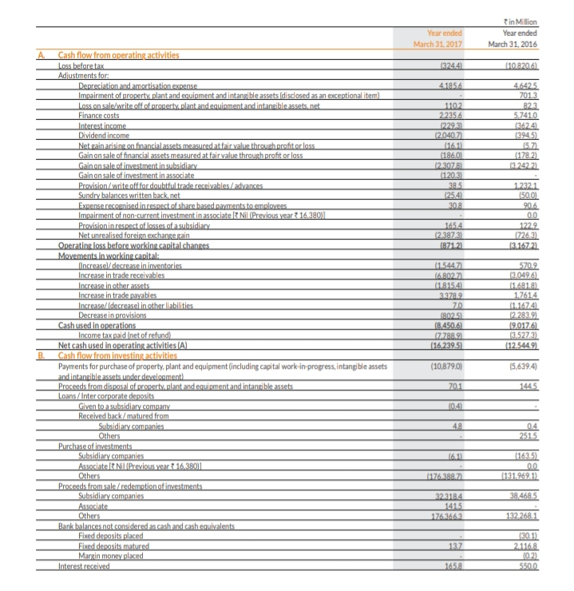**Annexure**

**Cash flow statement for the year ended march**

**31,2017**

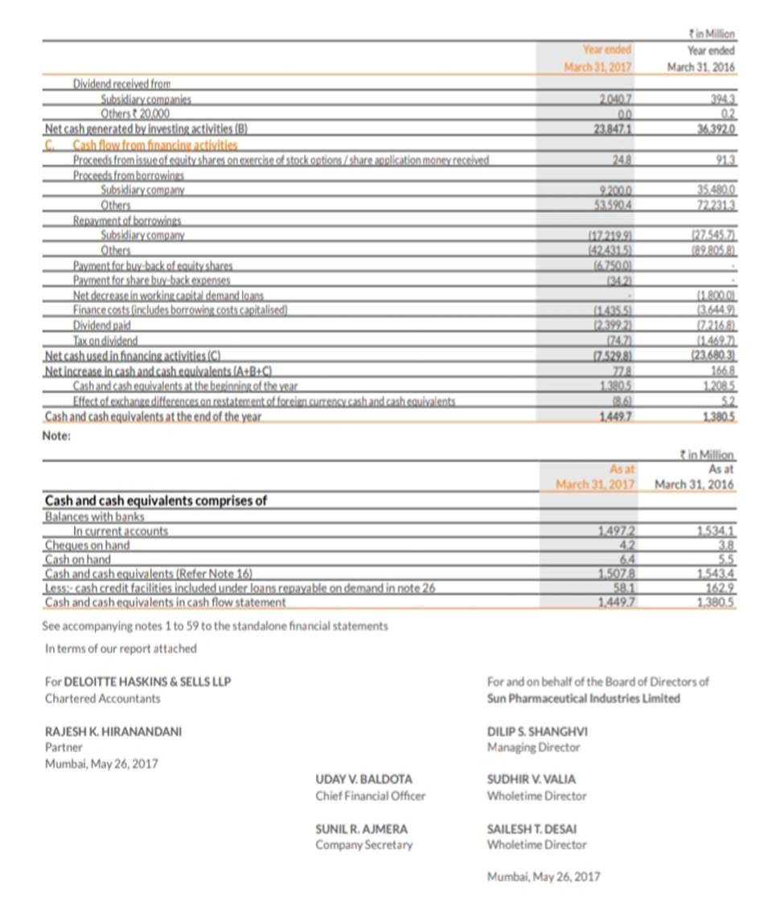

**Cash flow statement for the year ended march 31,2018**

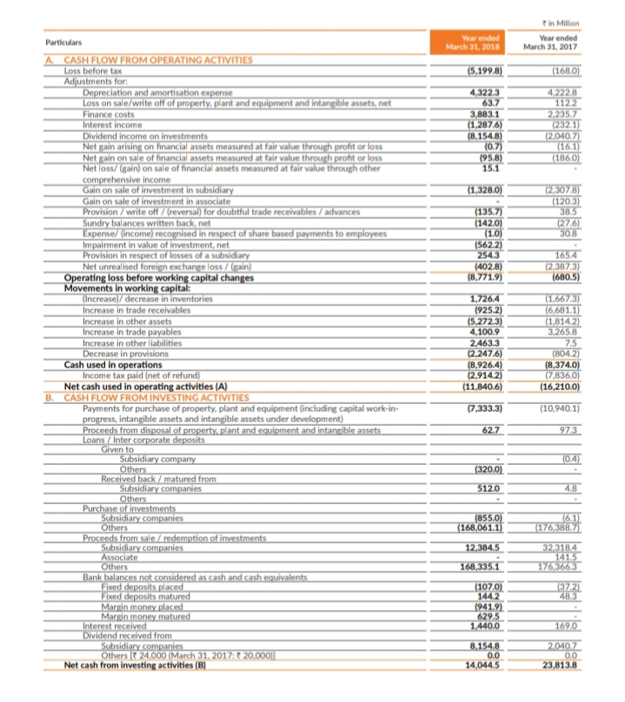

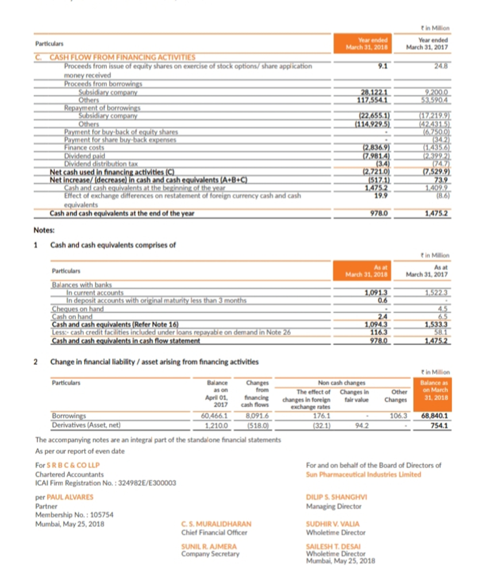

**Cash flow statement for the year ended march**

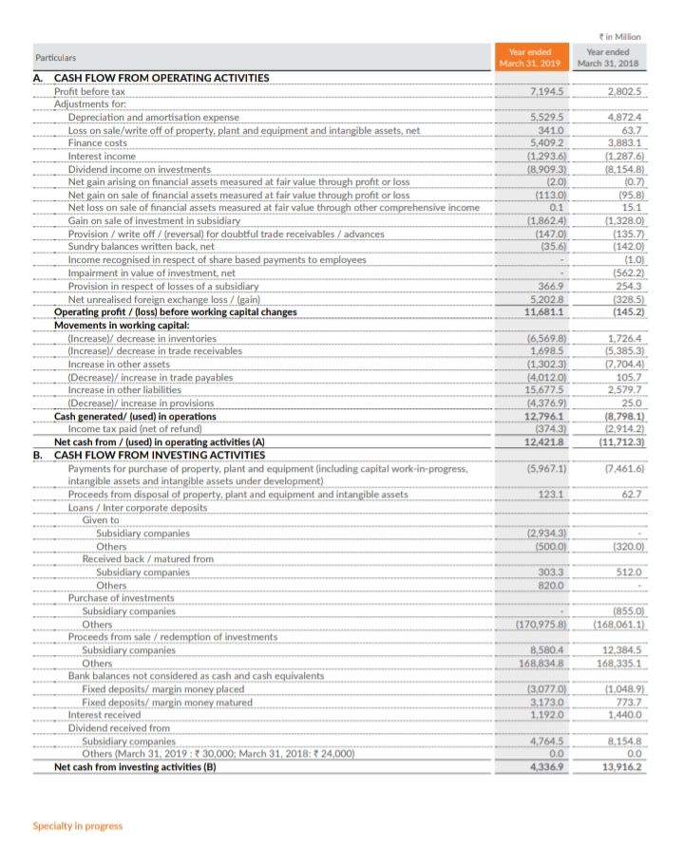**31,2019**

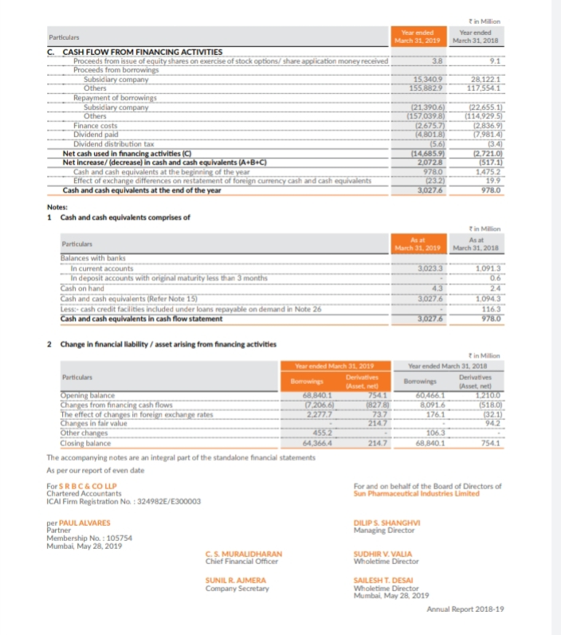

**Cash flow statement for the year ended march 31,2020**

